Práctica 5: Aprendizaje de redes neuronales
Esther Babon Arcauz

El primer paso fue leer los datos de entrada y usar la función de numpy eye para codificar el onehot de y.

Después codifique las funciones de coste sin regularizar y coste regularizado siguiendo las fórmulas proporcionadas en el enunciado de la práctica.

Una vez leídos los datos de pesos para las capas de la red neuronal probé las funciones de coste y vi que eran eran correctas.

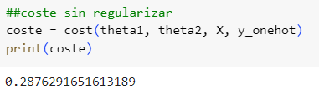
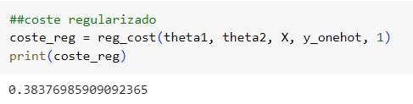

Para la función de coste tuve que implementar también las funciones auxiliares de sigmoide y propagación hacia delante.

Después implemente la función de propagación hacia delante usando la fórmula proporcionada en el enunciado de la práctica y comprobé que estaba bien usando la función de check Gradients de utils.

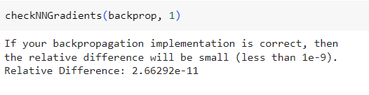

Para la parte de aprendizaje de los parámetros de entrada no me dio tiempo, lo añadiré en la práctica siguiente 🙁

import numpy as np
from matplotlib import pyplot
import scipy

def sigmoid(z):
return 1 / (1 + np.exp(-z))

def forward_prop(Theta1, Theta2, X):
m = X.shape[0]
a1 = np.hstack([np.ones([m, 1]), X])
z2 = np.matmul(a1, Theta1.T)
a2 = np.hstack([np.ones([m, 1]), sigmoid(z2)])
z3 = np.matmul(a2, Theta2.T)
a3 = sigmoid(z3)

return a1,a2,a3

def cost(theta1, theta2, X, y):
"""
Compute cost for 2-layer neural network.

Parameters
----------
theta1 : array_like
Weights for the first layer in the neural network.
It has shape (2nd hidden layer size x input size + 1)

theta2: array_like
Weights for the second layer in the neural network.
It has shape (output layer size x 2nd hidden layer size + 1)

X : array_like
The inputs having shape (number of examples x number of dimensions).

y : array_like
1-hot encoding of labels for the input, having shape
(number of examples x number of labels).

lambda_ : float
The regularization parameter.

Returns
-------
J : float
The computed value for the cost function.

"""
a1, a2, h = forward_prop(theta1,theta2, X)

term1 = y * np.log(h)
term2 = (1 - y) * np.log(1 - h)

J = (- 1 / (len(y))) * np.sum(term1 + term2)

return J

def reg_cost(theta1, theta2, X, y, lambda_):
"""
Compute cost for 2-layer neural network.

Parameters
----------
theta1 : array_like
Weights for the first layer in the neural network.
It has shape (2nd hidden layer size x input size + 1)

theta2: array_like
Weights for the second layer in the neural network.
It has shape (output layer size x 2nd hidden layer size + 1)

X : array_like
The inputs having shape (number of examples x number of dimensions).

y : array_like
1-hot encoding of labels for the input, having shape
(number of examples x number of labels).

lambda_ : float
The regularization parameter.

Returns
-------
J : float
The computed value for the cost function.

"""

J = cost(theta1, theta2, X, y)
term3 = np.sum(np.square(theta1[:,1:])) + np.sum(np.square(theta2[:,1:]))

J += (lambda_ / (2 * len(y))) * term3

return J

data = scipy.io.loadmat('ex3data1.mat', squeeze_me=True)
y = data['y']
X = data['X']
y_onehot = np.eye(10)[y]

wei = scipy.io.loadmat('ex3weights.mat', squeeze_me=True)
theta1 = wei['Theta1']
theta2 = wei['Theta2']

##coste sin regularizar
coste = cost(theta1, theta2, X, y_onehot)
print(coste)

##coste regularizado
coste_reg = reg_cost(theta1, theta2, X, y_onehot, 1)
print(coste_reg)

def backprop(theta1, theta2, X, y, lambda_):
"""
Compute cost and gradient for 2-layer neural network.

Parameters
----------
theta1 : array_like
Weights for the first layer in the neural network.
It has shape (2nd hidden layer size x input size + 1)

theta2: array_like
Weights for the second layer in the neural network.
It has shape (output layer size x 2nd hidden layer size + 1)

X : array_like
The inputs having shape (number of examples x number of dimensions).

y : array_like
1-hot encoding of labels for the input, having shape
(number of examples x number of labels).

lambda_ : float
The regularization parameter.

Returns
-------
J : float
The computed value for the cost function.

grad1 : array_like
Gradient of the cost function with respect to weights
for the first layer in the neural network, theta1.
It has shape (2nd hidden layer size x input size + 1)

grad2 : array_like
Gradient of the cost function with respect to weights
for the second layer in the neural network, theta2.
It has shape (output layer size x 2nd hidden layer size + 1)

"""
m = len(y)

Delta1 = np.zeros(np.shape(theta1))
Delta2 = np.zeros(np.shape(theta2))

a1, a2, H = forward_prop(theta1, theta2, X)

d3 = H - y
d2 = (np.dot(d3,theta2) * (a2 * (1 - a2)))[:,1:]
Delta1 = np.dot(d2.T, a1)
Delta2 = np.dot(d3.T, a2)

Delta1 = Delta1/m
Delta2 = Delta2/m
Delta1[:,1:] = Delta1[:,1:] + ( lambda_/m)*theta1[:,1:]
Delta2[:,1:] = Delta2[:,1:] + ( lambda_/m)*theta2[:,1:]

J = reg_cost(theta1, theta2, X, y, lambda_)
grad1 = Delta1
grad2 = Delta2

return (J, grad1, grad2)

